Chapter 10
Distribution and Network Models

Learning Objectives

1. Understand the usefulness of using optimization for supply chain problems.

2. Be able to identify the special features of the transportation problem.

3. Become familiar with the types of problems that can be solved by applying a transportation model.

4. Be able to develop network and linear programming models of the transportation problem.

5. Know how to handle the cases of (1) unequal supply and demand, (2) unacceptable routes, and (3) maximization objective for a transportation problem.

6. Be able to identify the special features of the assignment problem.

7. Become familiar with the types of problems that can be solved by applying an assignment model.

8. Be able to develop network and linear programming models of the assignment problem.

9. Be familiar with the special features of the transshipment problem.

10. Become familiar with the types of problems that can be solved by applying a transshipment model.

11 Be able to develop network and linear programming models of the transshipment problem.

12. Know the basic characteristics of the shortest route problem.

13. Be able to develop a linear programming model and solve the shortest route problem.

14. Know the basic characteristics of the maximal flow problem.

15. Be able to develop a linear programming model and solve the maximal flow problem.

16. Know how to structure and solve a production and inventory problem as a transshipment problem.

17. Understand the following terms:

network flow problem | capacitated transshipment problem
transportation problem | shortest route
origin | maximal flow
destination | source node
capacitated transportation problem | sink node
assignment problem | arc flow capacities
transshipment problem | supply chain

Solutions:

1. The network model is shown.
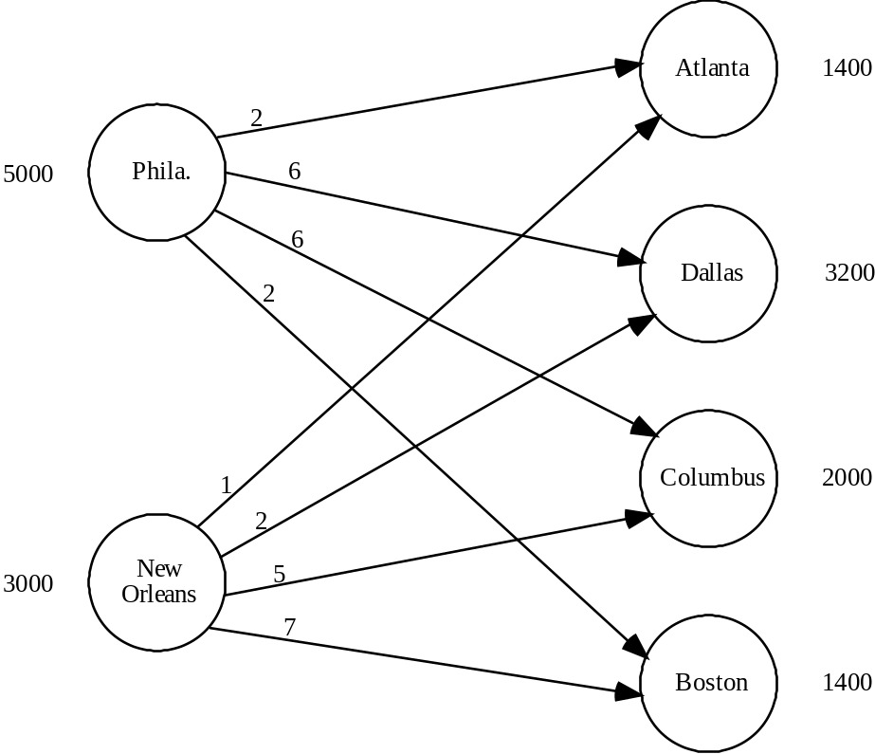
2. a.
Let |  | x11 |  | : | Amount shipped from Jefferson City to Des Moines
 |  | x12 |  | : | Amount shipped from Jefferson City to Kansas City
 |  | •
 |  | •
 |  | •
 | Min |  | 14x11 |  |  | + | 9x12 | + | 7x13 | + | 8x21 | + | 10x22 | + | 5x23
 | s.t.
 |  |  | x11 |  |  | + | x12 | + | x13 |  |  |  |  |  |  | ≤ | 30
 |  |  |  |  |  |  |  |  |  |  | x21 | + | x22 | + | x23 | ≤ | 20
 |  |  | x11 |  |  |  |  |  |  | + | x21 |  |  |  |  | = | 25
 |  |  |  |  |  |  | x12 |  |  |  |  | + | x22 |  |  | = | 15
 |  |  |  |  |  |  |  |  | x13 |  |  |  |  | + | x23 | = | 10

x11, x12, x13, x21, x22, x23, ≥ 0

b. Optimal Solution:
 | Amount | Cost
Jefferson City - Des Moines | 5 | 70
Jefferson City - Kansas City | 15 | 135
Jefferson City - St. Louis | 10 | 70
Omaha - Des Moines | 20 | 160
Total |  | 435
3. a.
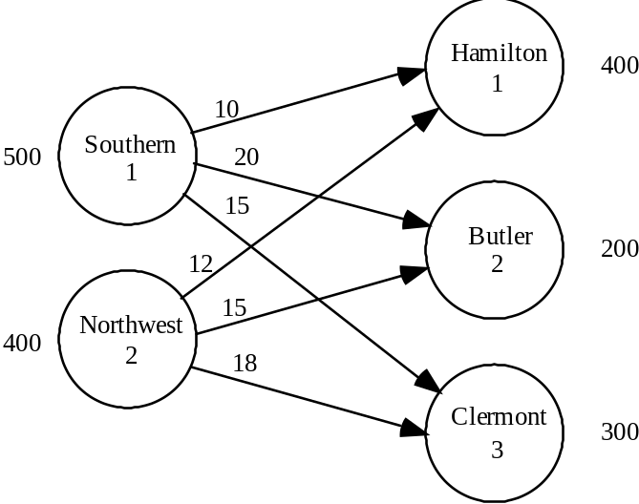

b. Let xij = amount shipped from supply node i to demand node j.

Min | 10x11 | + | 20x12 | + | 15x13 | + | 12x21 | + | 15x22 | + | 18x23
s.t.
 | x11 | + | x12 | + | x13 |  |  |  |  |  |  | ≤ | 500
 |  |  |  |  |  |  | x21 | + | x22 | + | x23 | ≤ | 400
 | x11 |  |  |  |  | + | x21 |  |  |  |  | = | 400
 |  |  | x12 |  |  |  |  | + | x22 |  |  | = | 200
 |  |  |  |  | x13 |  |  |  |  | + | x23 | = | 300

xij ≥ 0 for all i, j

c. Optimal Solution
 | Amount | Cost
Southern - Hamilton | 200 | $ 2000
Southern - Clermont | 300 | 4500
Northwest - Hamilton | 200 | 2400
Northwest - Butler | 200 | 3000
Total Cost |  | $11,900

d. To answer this question the simplest approach is to increase the Butler County demand to 300 and to increase the supply by 100 at both Southern Gas and Northwest Gas. The new optimal solution is:

 | Amount | Cost
Southern - Hamilton | 300 | $ 3000
Southern - Clermont | 300 | 4500
Northwest - Hamilton | 100 | 1200
Northwest - Butler | 300 | 4500
Total Cost |  | $13,200

From the new solution we see that Tri-County should contract with Southern Gas for the additional 100 units.
4.
    - The optimization model can be written as

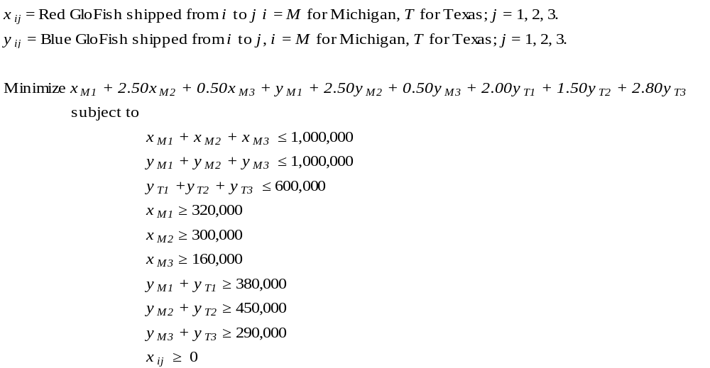
Solving this linear program using Excel Solver we find that we should produce 780,000 red GloFish in Michigan, 670,000 blue GloFish in Michigan, and 450,000 blue GloFish in Texas.
Using the notation in the model, the number of GloFish shipped from each farm to each retailer can be expressed as:

    - From Excel Solver, the minimum transportation cost is $2.35 million.

    - We have to add variables x_{T1}, x_{T2} and x_{T3} for Red GloFish shipped between Texas and Retailers 1, 2 and 3. The revised objective function is

We replace the third constraint above with
And we change the constraints
x_{M1} ≥ 320,000
x_{M2} ≥ 300,000
x_{M3} ≥ 160,000
to
x_{M1} + x_{T1} ≥ 320,000
x_{M2} + x_{T2} ≥ 300,000
x_{M3} + x_{T3} ≥ 160,000
Using this new objective function and constraint the optimal solution is $2.2 million, so the savings are $150,000.

5. a.

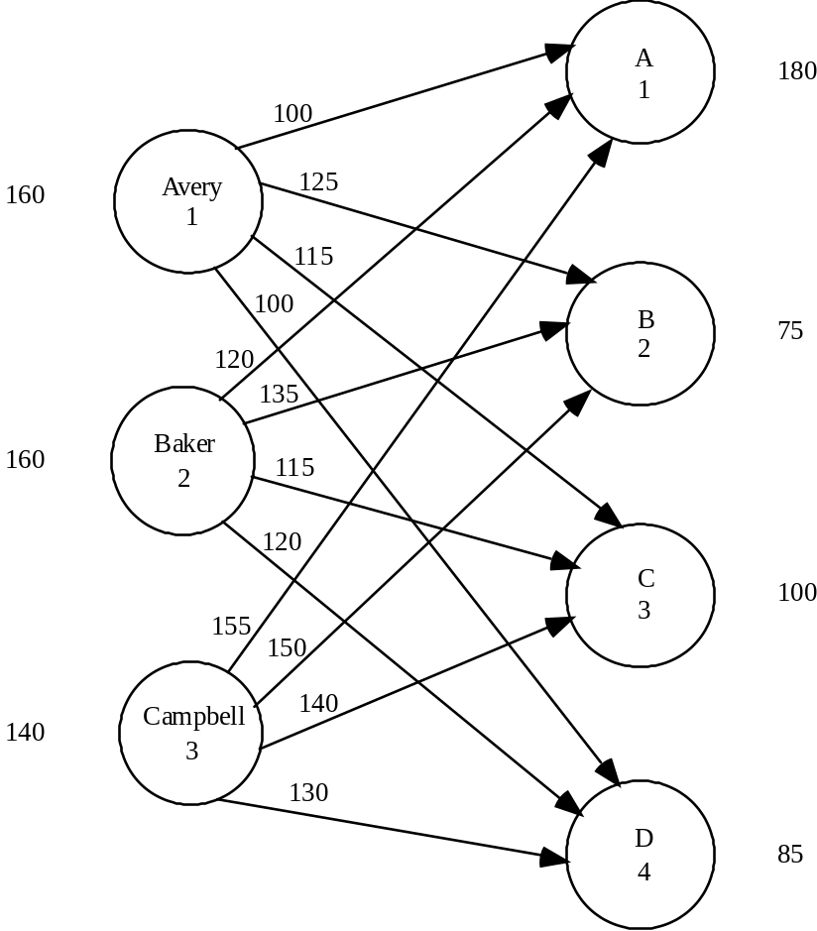

b. Let xij = number of hours from consultant i assigned to client j.

Max | 100x11 | + | 125x12 | + | 115x13 | + | 100x14 | + | 120x21 | + | 135x22 | + | 115x23
 |  | + | 120x24 | + | 155x31 | + | 150x32 | + | 140x33 | + | 130x34
s.t. | x11 | + | x12 | + | x13 | + | x14 |  |  |  |  |  |  |  |  | ≤ | 160
 |  |  |  |  | x21 | + | x22 | + | x23 | + | x24 |  |  |  |  | ≤ | 160
 |  |  |  |  |  |  |  |  | x31 | + | x32 | + | x33 | + | x34 | ≤ | 140
 | x11 |  |  | + | x21 |  |  | + | x31 |  |  |  |  |  |  | = | 180
 |  |  | x12 |  |  | + | x22 |  |  | + | x32 |  |  |  |  | = | 75
 |  |  |  |  | x13 |  |  | + | x23 |  |  | + | x33 |  |  | = | 100
 |  |  |  |  |  |  | x14 |  |  | + | x24 |  |  | + | x34 | = | 85
xij ≥ 0 for all i, j

Optimal Solution
 | Hours Assigned | Billing
Avery - Client B | 40 | $ 5,000
Avery - Client C | 100 | 11,500
Baker - Client A | 40 | 4,800
Baker - Client B | 35 | 4,725
Baker - Client D | 85 | 10,200
Campbell - Client A | 140 | 21,700
Total Billing |  | $57,925

c. New Optimal Solution
 | Hours Assigned | Billing
Avery - Client A | 40 | $ 4,000
Avery - Client C | 100 | 11,500
Baker - Client B | 75 | 10,125
Baker - Client D | 85 | 10,200
Campbell - Client A | 140 | 21,700
Total Billing |  | $57,525

6. The network model, the linear programming formulation, and the optimal solution are shown. Note that the third constraint corresponds to the dummy origin. The variables x31, x32, x33, and x34 are the amounts shipped out of the dummy origin; they do not appear in the objective function since they are given a coefficient of zero.
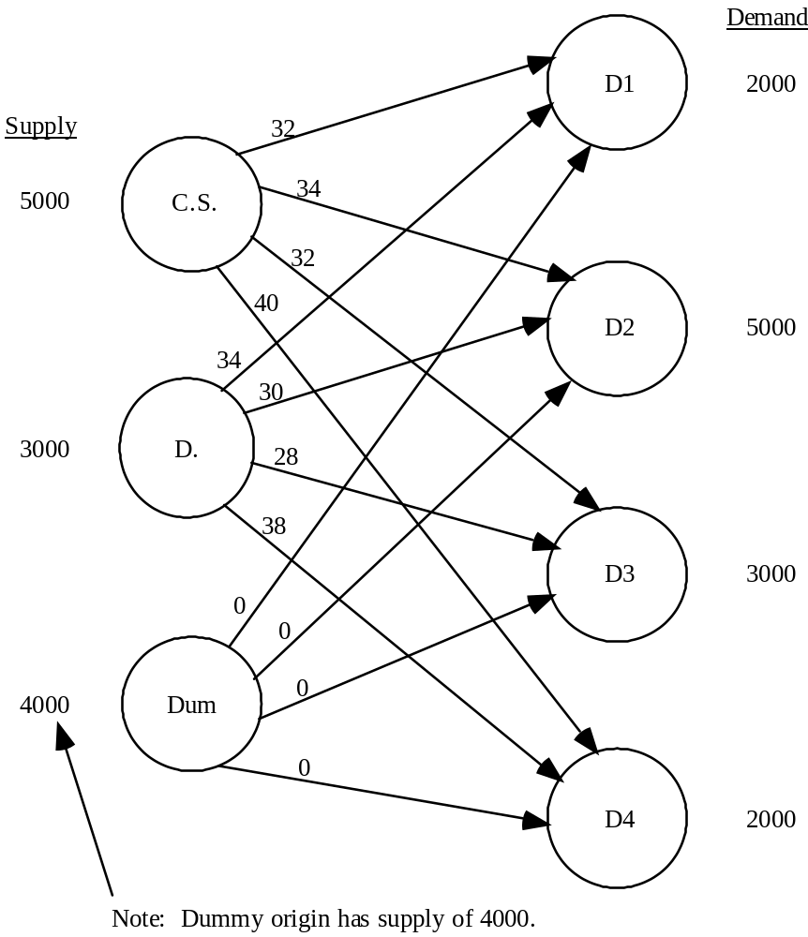

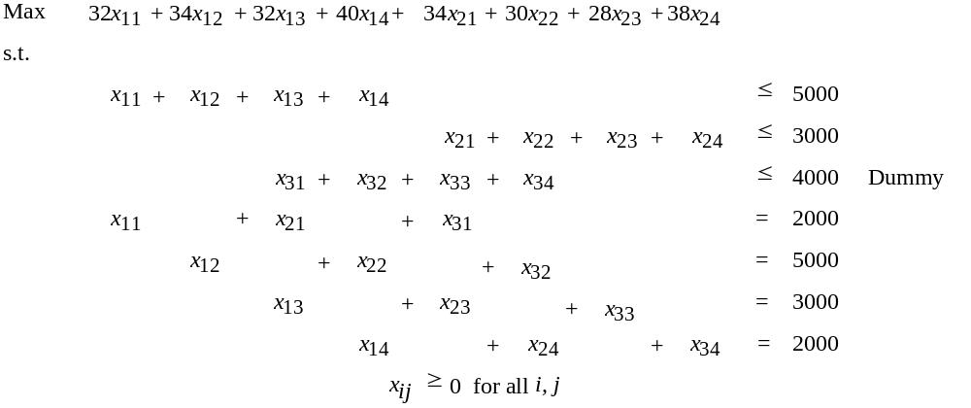

Optimal Solution Units Cost

Clifton Springs - D2 4000 $136,000
Clifton Springs - D4 1000 40,000
Danville - D1 2000 68,000
Danville - D4 1000 38,000
Total Cost: $282,000

Customer 2 demand has a shortfall of 1000

Customer 3 demand of 3000 is not satisfied.

7.
a. Let x_{ij} = MW produced at plant i for city j; i = L for Los Angeles, T for Tulsa, S for Seattle, j = 1, …, 10.

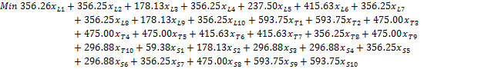

subject to
.00

By solving this linear program in Excel Solver, we find the optimal solution is to produce 6412.50 MWs in Los Angeles, 1543.75 MWs in Tulsa, and 2968.75 MWs in Seattle. The total distribution cost of this solution is $2,552,382.81.

- We must add the following constraints to the linear program shown above:
Solving the LP with these added constraints in Excel Solver yields an optimal production of 4000 MWs in Los Angeles, 2925 MWs in Tulsa, and 4000 MWs in Seattle at a total cost of $2,652,949.22. Therefore, the increase in cost associated with the additional constraints is $2,652,949.22 - $2,552,382.81 = $100,566.41.

8. a.

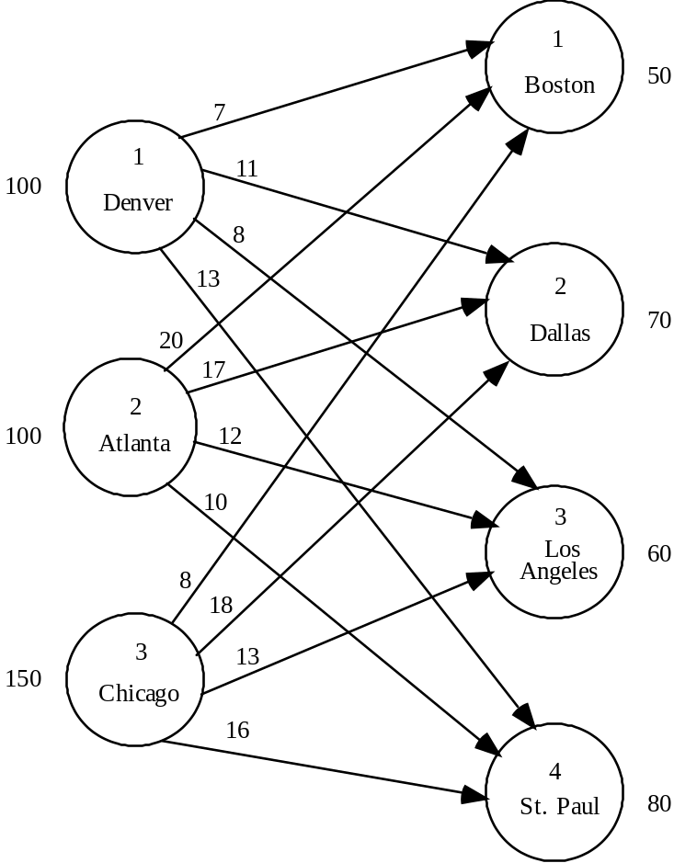
b. There are alternative optimal solutions.

Solution #1 | Solution # 2
Denver to St. Paul: 10 | Denver to St. Paul: 10
Atlanta to Boston: 50 | Atlanta to Boston: 50
Atlanta to Dallas: 50 | Atlanta to Los Angeles: 50
Chicago to Dallas: 20 | Chicago to Dallas: 70
Chicago to Los Angeles: 60 | Chicago to Los Angeles: 10
Chicago to St. Paul: 70 | Chicago to St. Paul: 70

Total Profit: $4240

If solution #1 is used, Forbelt should produce 10 motors at Denver, 100 motors at Atlanta, and 150 motors at Chicago. There will be idle capacity for 90 motors at Denver.

If solution #2 is used, Forbelt should adopt the same production schedule but a modified shipping schedule.

9. The linear programming formulation and optimal solution are shown.

Let | x1A | = | Units of product A on machine 1
 | x1B | = | Units of product B on machine 1
 | •
 | •
 | •
 | x3C | = | Units of product C on machine 3

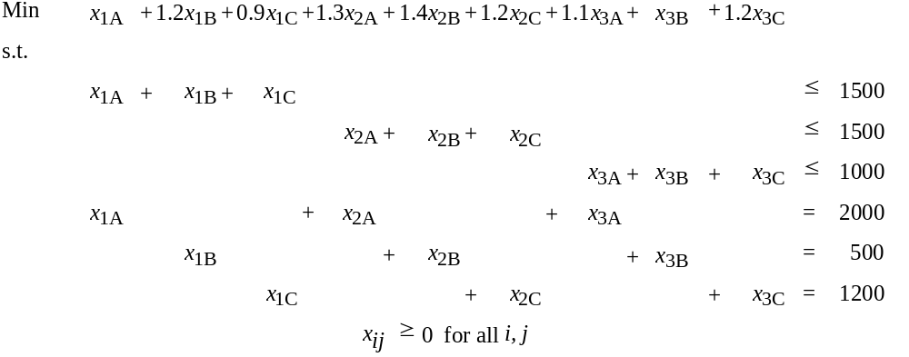

Optimal Solution Units Cost

1 - A 300 $ 300
1 - C 1200 1080
2 - A 1200 1560
3 - A 500 550
3 - B 500 500
Total: $3990

Note: There is an unused capacity of 300 units on machine 2.

10. a. The total cost is the sum of the purchase cost and the transportation cost. We show the calculation for Division 1 - Supplier 1 and present the result for the other Division-Supplier combinations.

Division 1 - Supplier 1
Purchase cost (40,000 x $12.60) | $504,000
Transportation Cost (40,000 x $2.75) | 110,000
Total Cost: | $614,000

Cost Matrix ($1,000s)
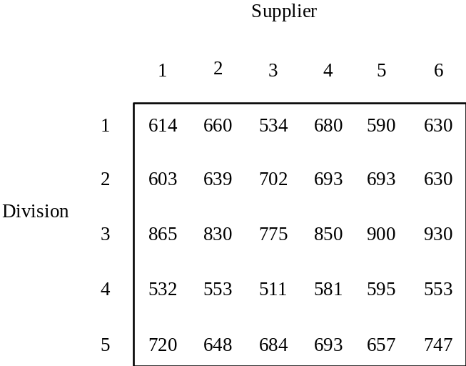

b. Optimal Solution:

Supplier 1 - Division 2 $ 603
Supplier 2 - Division 5 648
Supplier 3 - Division 3 775
Supplier 5 - Division 1 590
Supplier 6 - Division 4 553
Total $3,169

11. a. Network Model
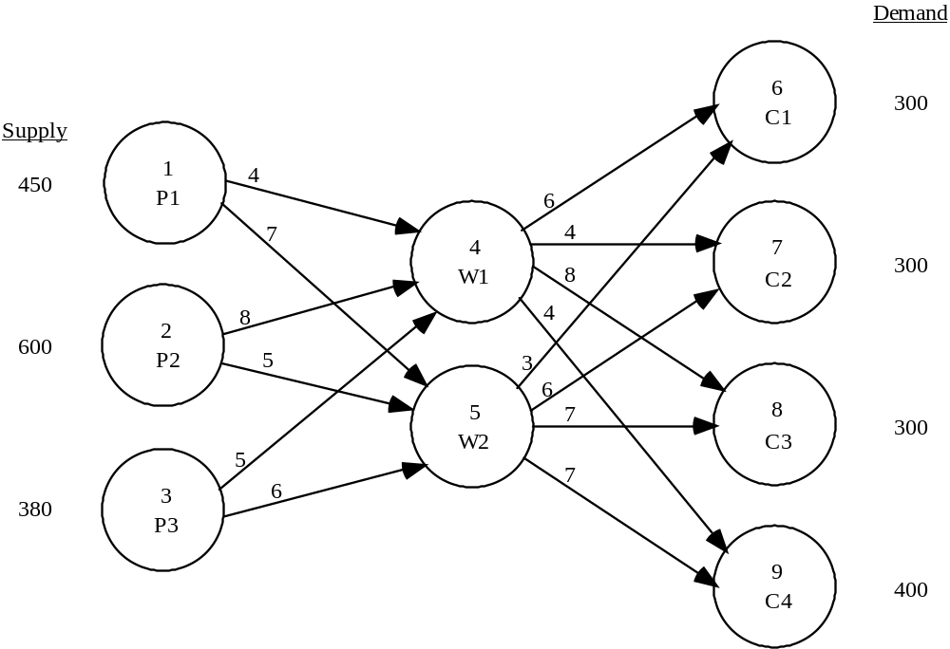

b. & c.
The linear programming formulation and solution is shown below.

LINEAR PROGRAMMING PROBLEM

MIN 4X14 + 7X15 + 8X24 + 5X25 + 5X34 + 6X35 + 6X46 + 4X47 + 8X48 + 4X49 + 3X56 + 6X57 + 7X58 + 7X59

S.T.

1) X14 + X15 < 450
2) X24 + X25 < 600
3) X34 + X35 < 380
4) X46 + X47 + X48 + X49 - X14 - X24 - X34 = 0
5) X56 + X57 + X58 + X59 - X15 - X25 - X35 = 0
6) X46 + X56 = 300
7) X47 + X57 = 300
8) X48 + X58 = 300
9) X49 + X59 = 400

OPTIMAL SOLUTION

Objective Function Value = 11850.000

Variable Value Reduced Costs
-------------- --------------- ------------------
X14 450.000 0.000
X15 0.000 3.000
X24 0.000 3.000
X25 600.000 0.000
X34 250.000 0.000
X35 0.000 1.000
X46 0.000 3.000
X47 300.000 0.000
X48 0.000 1.000
X49 400.000 0.000
X56 300.000 0.000
X57 0.000 2.000
X58 300.000 0.000
X59 0.000 3.000

There is an excess capacity of 130 units at plant 3.

12. a. Three arcs must be added to the network model in problem 23a. The new network is shown.

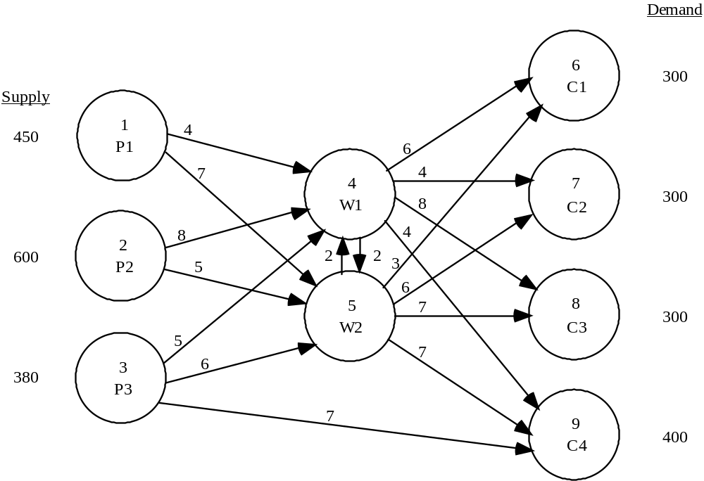

b.&c.
The linear programming formulation and optimal solution is shown below.

LINEAR PROGRAMMING PROBLEM

MIN 4X14 + 7X15 + 8X24 + 5X25 + 5X34 + 6X35 + 6X46 + 4X47 + 8X48 + 4X49 + 3X56 + 6X57 + 7X58 + 7X59 + 7X39 + 2X45 + 2X54

S.T.

1) X14 + X15 < 450
2) X24 + X25 < 600
3) X34 + X35 + X39 < 380
4) X45 + X46 + X47 + X48 + X49 - X14 - X24 - X34 - X54 = 0
5) X54 + X56 + X57 + X58 + X59 - X15 - X25 - X35 - X45 = 0
6) X46 + X56 = 300
7) X47 + X57 = 300
8) X48 + X58 = 300
9) X39 + X49 + X59 = 400

OPTIMAL SOLUTION

Objective Function Value = 11220.000

Variable Value Reduced Costs
-------------- --------------- ------------------
X14 320.000 0.000
X15 0.000 2.000
X24 0.000 4.000
X25 600.000 0.000
X34 0.000 2.000
X35 0.000 2.000
X46 0.000 2.000
X47 300.000 0.000
X48 0.000 0.000
X49 20.000 0.000
X56 300.000 0.000
X57 0.000 3.000
X58 300.000 0.000
X59 0.000 4.000
X39 380.000 0.000
X45 0.000 1.000
X54 0.000 3.000

The value of the solution here is $630 less than the value of the solution for problem 23. The new shipping route from plant 3 to customer 4 has helped (x39 = 380). There is now excess capacity of 130 units at plant 1.

13. a. Network Model

Demand
Supply
DC Capacity
8
Just Sports

1
Detroit
4
Iowa
25
25
30
27.5
200
350
500
35
30
500
40
20
5
Maryland
32.5
2
LA
9
Sports Stuff
356
45
40
500
350
35
500
42.5
35
40
6
Idaho
40
32.5
40
42.5
27.5
25
500
3
Austin
10
Sports Dude
650
700
7
Ark
32.5
42.5

- Let = units shipped from node i to node j

subject to
for all i and j.
Solving the formulation above using Excel Solver we get an optimal cost of $79,625 per week.

- Replace the seventh constraint above with . The optimal cost associated with this increased capacity at the Iowa distribution center is $79,250 per week. Therefore, the savings over 50 weeks is ($79,625 - $79,250) * 50 = $18,750 per year. The $40,000 cost of expansion exceeds the potential savings, so Sports of All Sorts should not expand.

14.
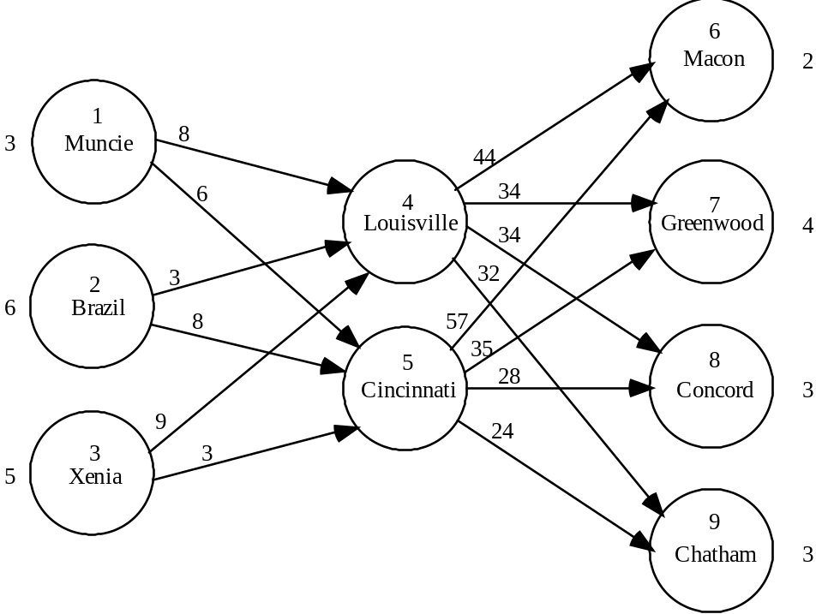

A linear programming model is

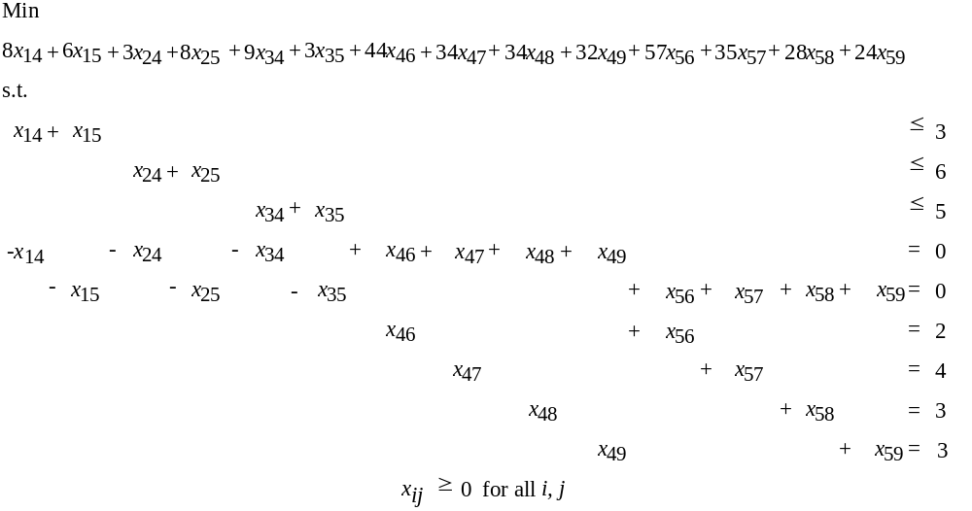

Optimal Solution Units Shipped Cost
Muncie to Cincinnati 1 6
Cincinnati to Concord 3 84
Brazil to Louisville 6 18
Louisville to Macon 2 88
Louisville to Greenwood 4 136
Xenia to Cincinnati 5 15
Cincinnati to Chatham 3 72
419

Two rail cars must be held at Muncie until a buyer is found.

15.
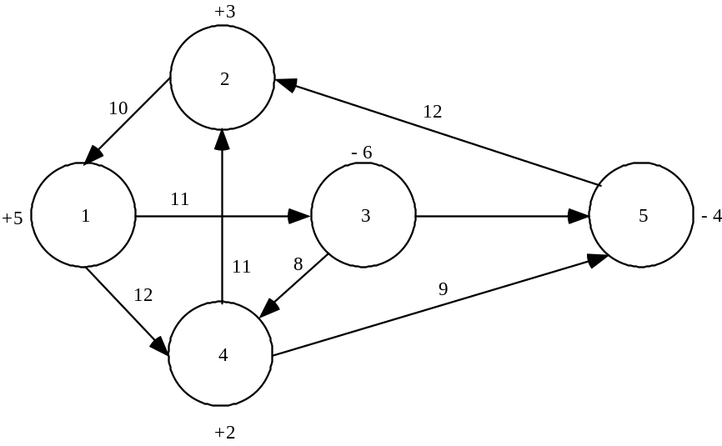

The positive numbers by nodes indicate the amount of supply at that node. The negative numbers by nodes indicate the amount of demand at the node.

16. a.
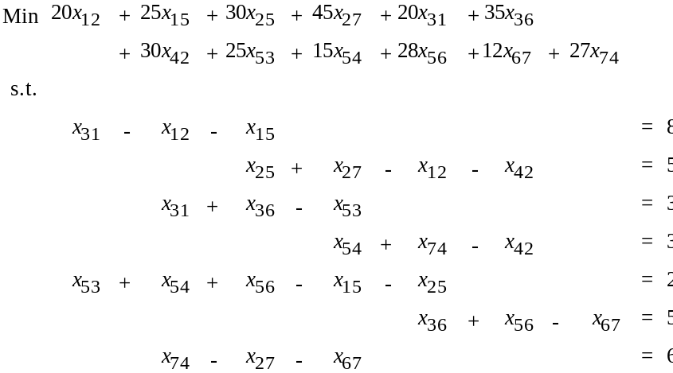
xij ≥ 0 for all i, j
b. x12 = 0 x53 = 5
x15 = 0 x54 = 0
x25 = 8 x56 = 5
x27 = 0 x67 = 0
x31 = 8 x74 = 6
x36 = 0 x56 = 5
x42 = 3

Total cost of redistributing cars = $917

17. a.

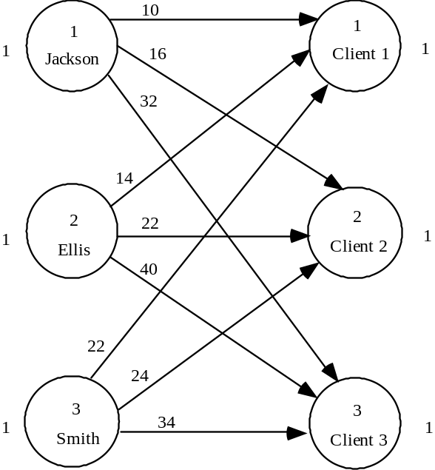

b.
Min | 10x11 | + | 16x12 | + | 32x13 | + | 14x21 | + | 22x22 | + | 40x23 | + | 22x31 | + | 24x32 | + | 34x33
s.t.
 | x11 | + | x12 | + | x13 |  |  |  |  |  |  |  |  |  |  |  |  | ≤ | 1
 |  |  |  |  |  |  | x21 | + | x22 | + | x23 |  |  |  |  |  |  | ≤ | 1
 |  |  |  |  |  |  |  |  |  |  |  |  | x31 | + | x32 | + | x33 | ≤ | 1
 | x11 |  |  |  |  | + | x21 |  |  |  |  | + | x31 |  |  |  |  | = | 1
 |  |  | x12 |  |  |  |  | + | x22 |  |  |  |  | + | x32 |  |  | = | 1
 |  |  |  |  | x13 |  |  |  |  | + | x23 |  |  |  |  | + | x33 | = | 1

xij ≥ 0 for all i, j

Solution x12 = 1, x21 = 1, x33 = 1 Total completion time = 64

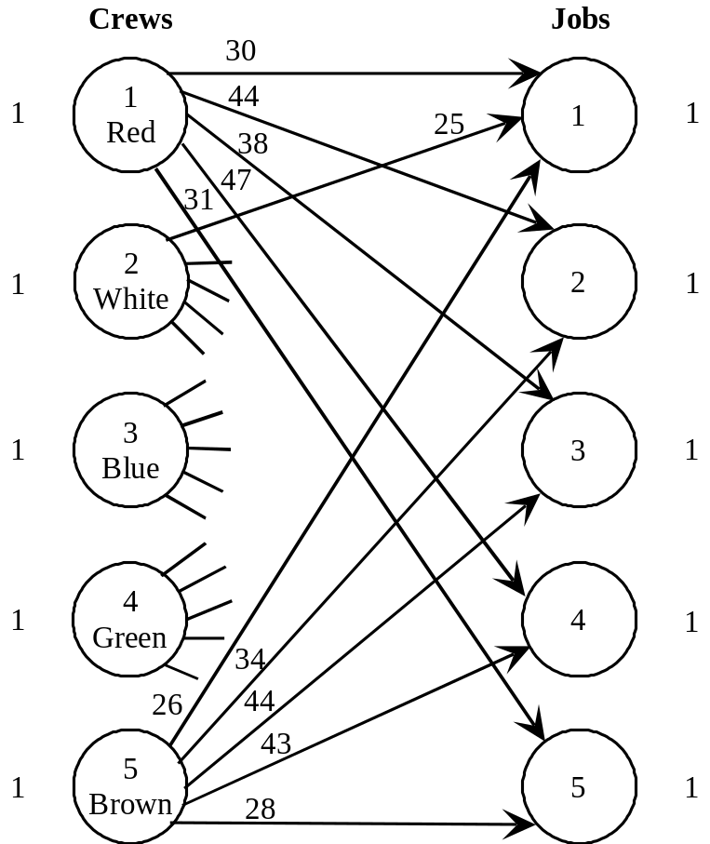18. a.

b.
Min | 30x₁₁ | + | 44x₁₂ | + | 38x₁₃ | + | 47x₁₄ | + | 31x₁₅ | + | 25x₂₁ | + |  | + | 28x₅₅
s.t.
 | x₁₁ | + | x₁₂ | + | x₁₃ | + | x₁₄ | + | x₁₅ |  |  |  |  |  |  |  | 1
 |  | x₂₁ | + | x₂₂ | + | x₂₃ | + | x₂₄ | + | x₂₅ |  |  |  |  |  |  | 1
 |  |  | x₃₁ | + | x₃₂ | + | x₃₃ | + | x₃₄ | + | x₃₅ |  |  |  |  |  | 1
 |  |  |  | x₄₁ | + | x₄₂ | + | x₄₃ | + | x₄₄ | + | x₄₅ |  |  |  |  | 1
 |  |  |  |  | x₅₁ | + | x₅₂ | + | x₅₃ | + | x₅₄ | + | x₅₅ |  |  |  | 1
 | x₁₁ | + | x₂₁ | + | x₃₁ | + | x₄₁ | + | x₅₁ |  |  |  |  |  |  | = | 1
 |  | x₁₂ | + | x₂₂ | + | x₃₂ | + | x₄₂ | + | x₅₂ |  |  |  |  |  | = | 1
 |  |  | x₁₃ | + | x₂₃ | + | x₃₃ | + | x₄₃ | + | x₅₃ |  |  |  |  | = | 1
 |  |  |  | x₁₄ | + | x₂₄ | + | x₃₄ | + | x₄₄ | + | x₅₄ |  |  |  | = | 1
 |  |  |  |  | x₁₅ | + | x₂₅ | + | x₃₅ | + | x₄₅ | + | x₅₅ |  |  | = | 1

x_{ij} ≥ 0, i = 1, 2,.., 5; j = 1, 2,.., 5

Optimal Solution:

Green to Job 1 | $26
Brown to Job 2 | 34
Red to Job 3 | 38
Blue to Job 4 | 39
White to Job 5 | 25
 | $162

Since the data is in hundreds of dollars, the total installation cost for the 5 contracts is $16,200.

19. This can be formulated as a linear program with a maximization objective function. There are 24 variables, one for each program/time slot combination. There are 10 constraints, 6 for the potential programs and 4 for the time slots.

Optimal Solution:

NASCAR Live 5:00 – 5:30 p.m.
Hollywood Briefings 5:30 – 6:00 p.m.
World News 7:00 – 7:30 p.m.
Ramundo & Son 8:00 – 8:30 p.m.

Total expected advertising revenue = $30,500

20. a. This is the variation of the assignment problem in which multiple assignments are possible. Each distribution center may be assigned up to 3 customer zones.

The linear programming model of this problem has 40 variables (one for each combination of distribution center and customer zone). It has 13 constraints. There are 5 supply (≤ 3) constraints and 8 demand (= 1) constraints.

The optimal solution is given below.

Assignments |  | Cost ($1000s)
Plano: | Kansas City, Dallas | 34
Flagstaff: | Los Angeles | 15
Springfield: | Chicago, Columbus, Atlanta | 70
Boulder: | Newark, Denver | 97
 | Total Cost - | $216

b. The Nashville distribution center is not used.

c. All the distribution centers are used. Columbus is switched from Springfield to Nashville. Total cost increases by $11,000 to $227,000.

21. A linear programming formulation and the optimal solution are given. For the decision variables, x_{ij}, we let the first subscript correspond to the supplier and the second subscript correspond to the distribution hub. Thus, x_{ij} = 1 if supplier i is awarded the bid to supply hub j and x_{ij} = 0 if supplier i is not awarded the bid to supply hub j.

Min 190x₁₁ +175x₁₂ + 125x₁₃ + 230x₁₄ + 150x₂₁ + 235x₂₂ + 155x₂₃ + 220x₂₄ + 210x₃₁ + 225x₃₂ + 135x₃₃ +260x₃₄ + 170x₄₁ + 185x₄₂ + 190x₄₃ + 280x₄₄ + 220x₅₁ + 190x₅₂ + 140x₅₃ + 240x₅₄ + 270x₆₁ + 200x₆₂ + 130x₆₃ + 260x₆₄
s.t.

x₁₁ |  | + x₁₂ |  | + x₁₃ |  | + x₁₄ |  |  |  |  |  | ≤ | 1
 | + x₂₁ |  | + x₂₂ |  | + x₂₃ |  | + x₂₄ |  |  |  |  | ≤ | 1
 |  | x₃₁ |  | + x₃₂ |  | + x₃₃ |  | + x₃₄ |  |  |  | ≤ | 1
 |  |  | x₄₁ |  | + x₄₂ |  | + x₄₃ |  | + x₄₄ |  |  | ≤ | 1
 |  |  |  | x₅₁ |  | + x₅₂ |  | + x₅₃ |  | + x₅₄ |  | ≤ | 1
 |  |  |  |  | x₆₁ |  | + x₆₂ |  | + x₆₃ |  | + x₆₄ | ≤ | 1
x₁₁ | + x₂₁ | + x₃₁ | + x₄₁ | + x₅₁ | + x₆₁ |  |  |  |  |  |  | = | 1
 |  | x₁₂ | + x₂₂ | + x₃₂ | + x₄₂ | + x₅₂ | + x₆₂ |  |  |  |  | = | 1
 |  |  |  | x₁₃ | + x₂₃ | + x₃₃ | + x₄₃ | + x₅₃ | + x₆₃ |  |  | = | 1
 |  |  |  |  |  | x₁₄ | + x₂₄ | + x₃₄ | + x₄₄ | + x₄₅ | + x₄₆ | = | 1

x_{ij} ≥ 0 for all i, j

Optimal Solution Bid

Martin – Hub 2 175
Schmidt Materials – Hub 4 220
D&J Burns – Hub 1 170
Lawler Depot – Hub 3 130
695

22. A linear programming formulation of this problem can be developed as follows. Let the first letter of each variable name represent the professor and the second two the course. Note that a DPH variable is not created because the assignment is unacceptable.

Max | 2.8AUG | + | 2.2AMB | + | 3.3AMS | + | 3.0APH | + | 3.2BUG | + | · · · | + | 2.5DMS
s.t.
 | AUG | + | AMB | + | AMS | + | APH |  |  |  |  |  |  | ≤ | 1
 |  |  | BUG | + | BMB | + | BMS | + | BPH |  |  |  |  | ≤ | 1
 |  |  |  |  | CUG | + | CMB | + | CMS | + | CPH |  |  | ≤ | 1
 |  |  |  |  |  |  | DUG | + | DMB | + | DMS |  |  | ≤ | 1
 | AUG | + | BUG | + | CUG | + | DUG |  |  |  |  |  |  | = | 1
 |  |  | AMB | + | BMB | + | CMB | + | DMB |  |  |  |  | = | 1
 |  |  |  |  | AMS | + | BMS | + | CMS | + | DMS |  |  | = | 1
 |  |  |  |  |  |  | APH | + | BPH | + | CPH |  |  | = | 1
All Variables ≥ 0

Optimal Solution: | Rating
A to MS course | 3.3
B to Ph.D. course | 3.6
C to MBA course | 3.2
D to Undergraduate course | 3.2
Max Total Rating | 13.3

23. Origin – Node 1

Transshipment Nodes 2 to 5

Destination – Node 7

The linear program will have 14 variables for the arcs and 7 constraints for the nodes.

Let 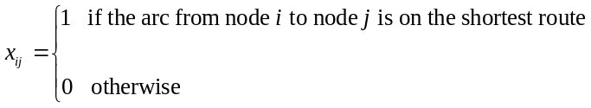

Min
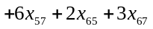
s.t.
Flow Out Flow In
Node 1 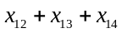 = 1
Node 2 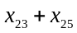 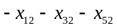 = 0
Node 3 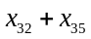 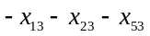 = 0
Node 4 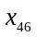 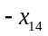 = 0
Node 5 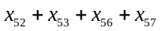 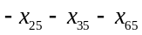 = 0
Node 6 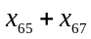 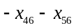 = 0
Node 7 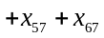 = 1

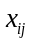 > 0 for all i and j
Optimal Solution: 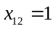, 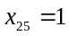, 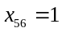, and 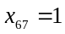

Shortest Route 1-2-5-6-7

Length = 17

24. The linear program has 13 variables for the arcs and 6 constraints for the nodes. Use same six constraints for the Gorman shortest route problem as shown in the text. The objective function changes to travel time as follows.

Min 40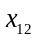 + 36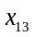 + 6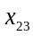 + 6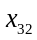 + 12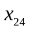 + 12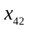 + 25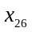 + 15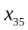 + 15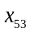
+ 8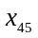 + 8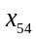 + 11+ 23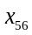
Optimal Solution: , 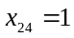, and 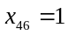

Shortest Route 1-2-4-6

Total Time = 63 minutes

25. a. Origin – Node 1

Transshipment Nodes 2 to 5

Destination – Node 6

The linear program will have 13 variables for the arcs and 6 constraints for the nodes.

Let

Min
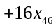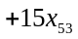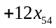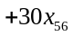
s.t.
Flow Out Flow In
Node 1 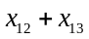 = 1
Node 2 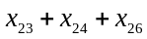 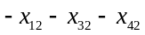 = 0
Node 3 = 0
Node 4 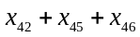 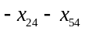 = 0
Node 5 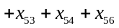 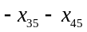 = 0
Node 6 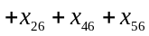 = 1

> 0 for all I and j
b. Optimal Solution: , , and

Shortest Route 1-2-4-6

Total time = 69 minutes

c. Allowing 8 minutes to get to node 1 and 69 minutes to go from node 1 to node 6, we expect to make the delivery in 77 minutes. With a 20% safety margin, we can guarantee a delivery in 1.2(77) = 92 minutes. It is 1:00 p.m. now. Guarantee delivery by 2:32 p.m.

26. Origin – Node 1

Transshipment Nodes 2 to 5 and node 7

Destination – Node 6

The linear program will have 18 variables for the arcs and 7 constraints for the nodes.

Let

Min
s.t.
Flow Out Flow In
Node 1 = 1
Node 2 = 0
Node 3 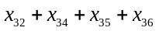 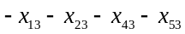 = 0
Node 4 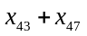 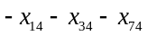 = 0
Node 5 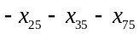 = 0
Node 6 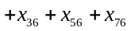 = 1
Node 7 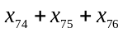 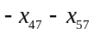 = 0

> 0 for all i and j

Optimal Solution: 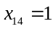, 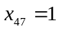, and 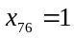

Shortest Route 1-4-7-6

Total Distance = 40 miles

27. Origin – Node 1

Transshipment Nodes 2 to 9

Destination – Node 10 (Identified by the subscript 0)

The linear program will have 29 variables for the arcs and 10 constraints for the nodes.

Let

Min
s.t.
Flow Out Flow In
Node 1 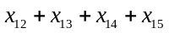 = 1
Node 2 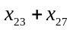 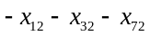 = 0
Node 3 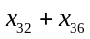 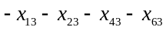 = 0
Node 4 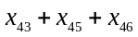 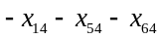 = 0
Node 5 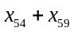 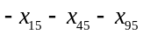 = 0
Node 6 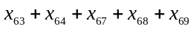 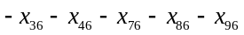 = 0
Node 7 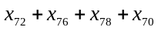 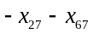 = 0
Node 8 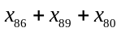 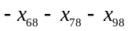 = 0
Node 9 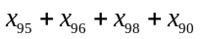 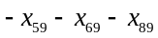 = 0
Node 10 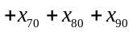 = 1

> 0 for all i and j
Optimal Solution: 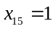, 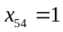, , , and 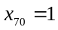

Shortest Route 1-5-4-6-7-10

Total Time = 25 minutes

28. Origin – Node 0

Transshipment Nodes 1 to 3

Destination – Node 4

The linear program will have 10 variables for the arcs and 5 constraints for the nodes.

Let 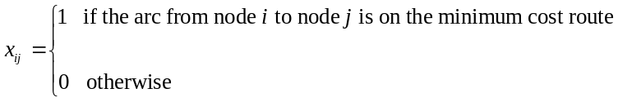

Min
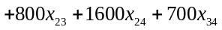
s.t.
Flow Out Flow In
Node 0 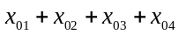 = 1
Node 1 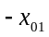 = 0
Node 2 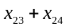 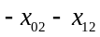 = 0
Node 3 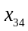 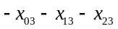 = 0
Node 4 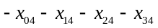 = 1

> 0 for all i and j
Optimal Solution: 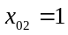, 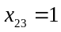, and 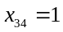

Shortest Route 0-2-3-4

Total Cost = $2500

29. The capacitated transshipment problem to solve is given:

Max x₆₁
s.t.
x₁₂ + x₁₃ + x₁₄ - x₆₁ = 0
x₂₄ + x₂₅ - x₁₂ - x₄₂ = 0
x₃₄ + x₃₆ - x₁₃ - x₄₃ = 0
x₄₂ + x₄₃ + x₄₅ + x₄₆ - x₁₄ - x₂₄ - x₃₄ - x₅₄ = 0
x₅₄ + x₅₆ - x₂₅ - x₄₅ = 0
x₆₁ - x₃₆ + x₄₆ - x₅₆ = 0

x₁₂ ≤ 2 x₁₃ ≤ 6 x₁₄ ≤ 3
x₂₄ ≤ 1 x₂₅ ≤ 4
x₃₄ ≤ 3 x₃₆ ≤ 2
x₄₂ ≤ 1 x₄₃ ≤ 3 x₄₅ ≤ 1 x₄₆ ≤ 3
x₅₄ ≤ 1 x₅₆ ≤ 6

x_{ij} ≥ 0 for all i, j

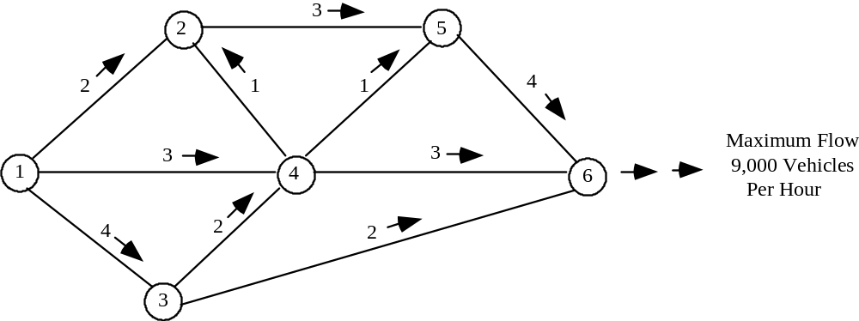
The system cannot accommodate a flow of 10,000 vehicles per hour.

30.
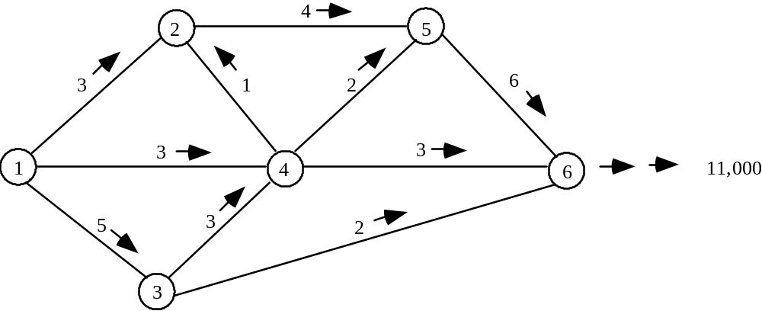

31. The maximum number of messages that may be sent is 10,000.

32. a. 10,000 gallons per hour or 10 hours

b. Flow reduced to 9,000 gallons per hour; 11.1 hours.

33. Current Max Flow = 6,000 vehicles/hour.

With arc 3-4 at a 3,000 unit/hour flow capacity, total system flow is increased to 8,000 vehicles/hour. Increasing arc 3-4 to 2,000 units/hour will also increase system to 8,000 vehicles/hour. Thus a 2,000 unit/hour capacity is recommended for this arc.

34. Maximal Flow = 23 gallons / minute. Five gallons will flow from node 3 to node 5.

35. a. Modify the problem by adding two nodes and two arcs. Let node 0 be a beginning inventory node with a supply of 50 and an arc connecting it to node 5 (period 1 demand). Let node 9 be an ending inventory node with a demand of 100 and an arc connecting node 8 (period 4 demand to it).

b.
Min |  | + | 2x15 | + | 5x26 | + | 3x37 | + | 3x48 | + | 0.25x56 | + | 0.25x67 | + | 0.25x78 | + | 0.25x89
s.t.
 | x05 |  |  |  |  |  |  |  |  |  |  |  |  |  |  |  |  | = | 50
 |  |  | x15 |  |  |  |  |  |  |  |  |  |  |  |  |  |  | ≤ | 600
 |  |  |  |  | x26 |  |  |  |  |  |  |  |  |  |  |  |  | ≤ | 300
 |  |  |  |  |  |  | x37 |  |  |  |  |  |  |  |  |  |  | ≤ | 500
 |  |  |  |  |  |  |  |  | x48 |  |  |  |  |  |  |  |  | ≤ | 400
 | x05 | + | x15 |  |  |  |  |  |  | - | x56 |  |  |  |  |  |  | = | 400
 |  |  |  |  | x26 |  |  |  |  | + | x56 | - | x67 |  |  |  |  | = | 500
 |  |  |  |  |  |  | x37 |  |  |  |  | + | x67 | - | x78 |  |  | = | 400
 |  |  |  |  |  |  |  |  | x48 |  |  |  |  | + | x78 | - | x89 | = | 400
 |  |  |  |  |  |  |  |  |  |  |  |  |  |  |  |  | x89 | = | 100
xij ≥ 0 for all i and j

Optimal Solution:

x05 = 50 x56 = 250
x15 = 600 x67 = 0
x26 = 250 x78 = 100
x37 = 500 x89 = 100
x48 = 400

Total Cost = $5262.50

36. a. Let R1, R2, R3 represent regular time production in months 1, 2, 3
O1, O2, O3 represent overtime production in months 1, 2, 3
D1, D2, D3 represent demand in months 1, 2, 3

Using these 9 nodes, a network model is shown.

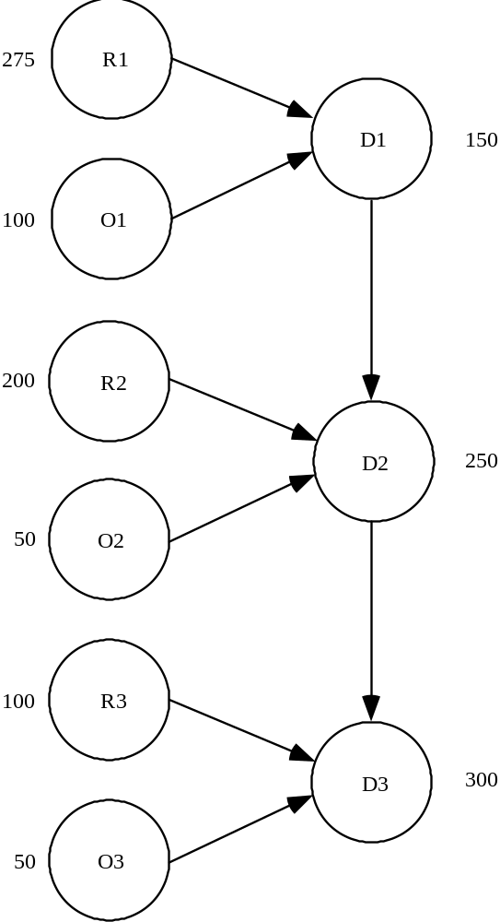

b. Use the following notation to define the variables: first two letters designates the "from node" and the second two letters designates the "to node" of the arc. For instance, R1D1 is amount of regular time production available to satisfy demand in month 1, O1D1 is amount of overtime production in month 1 available to satisfy demand in month 1, D1D2 is the amount of inventory carried over from month 1 to month 2, and so on.

MIN 50R1D1 + 80O1D1 + 20D1D2 + 50R2D2 + 80O2D2 + 20D2D3 + 60R3D3 + 100O3D3

S.T.

1) R1D1 ≤ 275
2) O1D1 ≤ 100
3) R2D2 ≤ 200
4) O2D2 ≤ 50
5) R3D3 ≤ 100
6) O3D3 ≤ 50
7) R1D1 + O1D1 - D1D2 = 150
8) R2D2 + O2D2 + D1D2 - D2D3 = 250
9) R3D3 + O3D3 + D2D3 = 300

c. Optimal Solution:

Variable Value
-------------- ---------------
R1D1 275.000
O1D1 25.000
D1D2 150.000
R2D2 200.000
O2D2 50.000
D2D3 150.000
R3D3 100.000
O3D3 50.000

Value = $46,750

Note: Slack variable for constraint 2 = 75.

d. The values of the slack variables for constraints 1 through 6 represent unused capacity. The only nonzero slack variable is for constraint 2; its value is 75. Thus, there are 75 units of unused overtime capacity in month 1.

